**EXPERIMENTAL REPORT**

2021B1436: Structural Investigation of Novel Ternary Y-Mg and La-Mg Hydrides - Near Room-temperature Superconductors

Dmitrii Semenok, Ivan Troyan, Mikhail Kuzovnikov, Di Zhou, Yuki Nakamoto and Katsuya Shimizu

**Research goals**

Within this project we proposed to study ternary polyhydrides of lanthanum synthesized in high-pressure diamond anvil cells (DAC) using NH3BH3 as a source of hydrogen. It was planned to investigate all newly found phases by synchrotron X-ray to determine their crystal structure, phase transformations and equations of state. Within this proposal, we planned to study the formation of new polyhydrides in Y-Mg-H (DAC MgY), La-Mg-H systems at 150-180 GPa. Due to complications in the synthesis of initial precursors (La-Mg alloys), the study of La-Mg-H system was replaced by investigation of the Ca-Y-H system (DAC CaY).

**Results**

The parameters of DACs MgY and CaY, loaded by MgYH5-x and CaYH5 respectively, are given in Table 1. Initial calcium and yttrium hydrides were obtained by direct synthesis from the metals and hydrogen at pressure 20 bar and temperature 400 oС. X-ray diffraction (XRD) analysis shows that the reaction products of calcium and yttrium with hydrogen are almost pure *Pnma*-CaH2 (a = 5.9664 Å, b = 3.6081 Å, c = 6.8261 Å) and *P*63/*mmc*-YH3 (a = 3.6771 Å, c = 6.6153 Å) with a small admixture of cubic Y2O3 (~12 at. %). Magnesium hydride *P*42/*mnm*-MgH2 (a = 4.5177 Å, c = 3.0217 Å) was purchased from Sigma Aldrich and, according to XRD, contained 92 at. % MgH2, 6 % Mg(OH)2 and 2 % Mg.

**Table 1.** Experimental parameters of the DACs used for the X‑ray diffraction studies. Data in the second column corresponds to the pressure of the laser-assisted synthesis.

|  |  |  |  |  |
| --- | --- | --- | --- | --- |
| #cell | Pressure, GPa | Culet diameter,  μm | Sample size, μm | Composition |
| MgY | 175 | 50 | 21 | MgYH5-x/BH3NH3 |
| CaY | 177 | 50 | 28 | CaYH5/BH3NH3 |

Material for high-pressure synthesis of ternary Mg-Y polyhydrides was made from MgH2 (V = 30.835 Å3/Mg) and YH3 (V = 38.73 Å3/Y) mixed in a ratio of 1:1 and ground in a ball mill (500 rps) during 1 hour in hydrogen atmosphere at 77 K. As a result of the mechanochemical reaction, a face-centered cubic phase was formed with the unit cell parameter a = 5.16 Å, and unit cell volume V = 34.26 Å3/(Mg,Y) atom (Figure 1a). Earlier in the literature, it was reported about the *fcc* Mg-Y hydride of the composition MgY2H8 with a similar lattice parameter [*Materials Transactions*, Vol. 43, No. 11 (2002) pp. 2717 to 2720]. The mixture also contained an impurity phase with cell parameters close to *hcp*-YH3 (a = 3.6873 Å, c = 6.5490 Å). Cell volume of the main phase per 0.52 Å3/metal atom lower, than cell volume of MgYH5, therefore, in the following, we will denote the resulting compound as MgYH5-x or (Mg,Y)2H5-x. Moreover, the last formula reflects the fact that the Mg and Y atoms are randomly distributed in metal positions of the obtained compound. (Mg,Y)2H5-x is opaque to visible light, which indicates a narrow band gap.

Material for high-pressure synthesis of ternary Ca-Y polyhydrides was prepared from CaH2 (V = 36.74 Å3/Ca) and YH3 (V = 38.73 Å3/Y) mixed in a ratio of 1:1 and ground in a ball mill (500 rps) during 1 hour in hydrogen atmosphere at room temperature. As a result of the mechanochemical reaction, a pure face-centered cubic phase of gray color was formed with the unit cell parameter a = 5.34 Å, and the volume V = 37.84 Å3 per metal atom (Figure 1b), never seen before in the system Ca-Y-H. Since the volume of the resulting phase lies exactly between the volumes of CaH2 and YH3, and there are no additional reflections in the XRD pattern, corresponding to two separate Ca and Y sublattices, we will denote obtained hydride as CaYH5 or (Ca,Y)2H5. The last formula reflects the fact that Ca and Y atoms are randomly distributed in the metal sites. This compound is opaque to visible light, which indicates a narrow band gap in the electronic structure of the synthesized hydride.

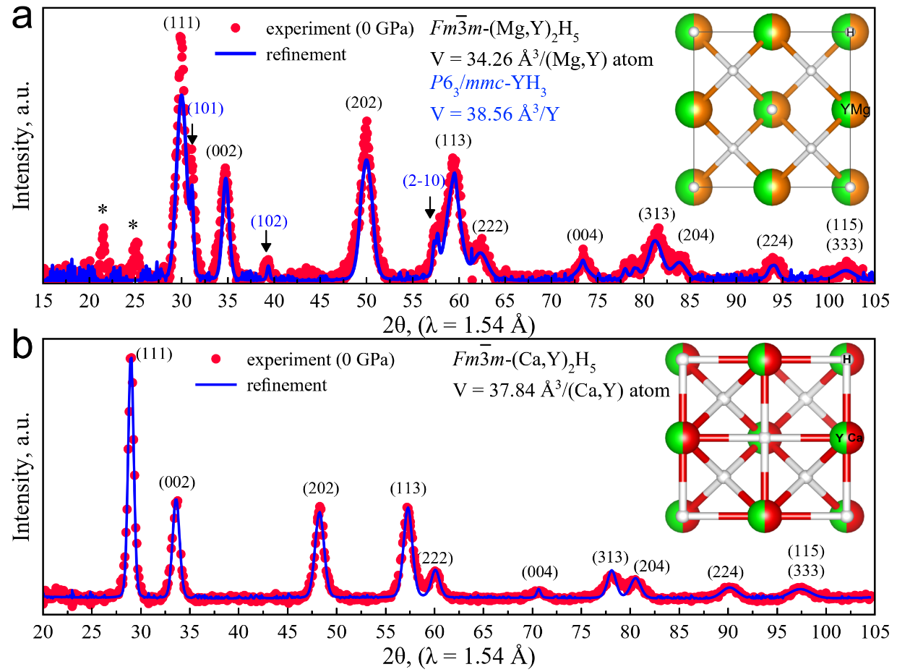

**Figure 1.** Experimental X-ray diffraction patterns of cubic (Mg,Y)2H5-x (a) and (Ca,Y)2H5 (b) precursors at 0 GPa. The experimental data and fitted line are shown in red and blue, respectively. Unexplained weak reflections are marked by asterisks (21.5 and 25.1°, (a)). Inset: proposed candidate structure *Pnm*-(X,Y)4H10.

The samples d~20-30 μm were loaded into diamond cells with a 50 μm culet diameter (Figure 2). CaF2/epoxy was used as gasket. Pulsed laser heating of (Mg,Y)2H5-x and (Ca,Y)2H5 samples mixed with NH3BH3, was carried out at 1200-1500 K with duration of several hundred microseconds. After the heating the samples expanded, became black, and the pressure in DACs, measured via Raman signals of diamond, was 175 (MgY) and 177 (CaY) GPa. Within this work the pressure in the DACs was determined via the Raman signal of diamond [Eremets, M. I., *J. Raman Spectrosc.* 34, 515–518 (2003)]. Unfortunately, the X-ray diffraction from the MgYHx sample was not strong enough to be detected in this experiment. Perhaps the reason for the failure is the small size (~20 μm) and thickness (~ 1 μm) of the sample, as well as the lower scattering coefficient of Mg compared to Ca atoms.

The study of calcium-yttrium hydrides was more successful. The product is a mixture of several coarse-grained phases (Figure 3). All phases were found to be stable in the investigated pressure range: 119-177 GPa. As the analysis of diffraction patterns shows, the main product of the reaction of cubic (Ca,Y)2H5 with hydrogen is new polyhydride *Rm*-(Ca,Y)H5 (V = 19.16 Å3/metal atom at 177 GPa), while impurity phases are *Imm*-CaH6 (additional reflection intensity at (2 $\overline{1}$ 0) in Figure 3a, V = 20.02 Å3/Ca at 177 GPa) and *P*1-YH7 (diffraction peaks at 8-10o, Figure 3a) previously discovered by us in the study of the Y-H system [Advanced Materials 2021]. The experimental parameters of the unit cell are given in Table 2. The cell volume of impurity cubic CaH6 is in excellent agreement with previously published data [Liang Ma et al., <https://arxiv.org/abs/2103.16282>] (Figure 4).

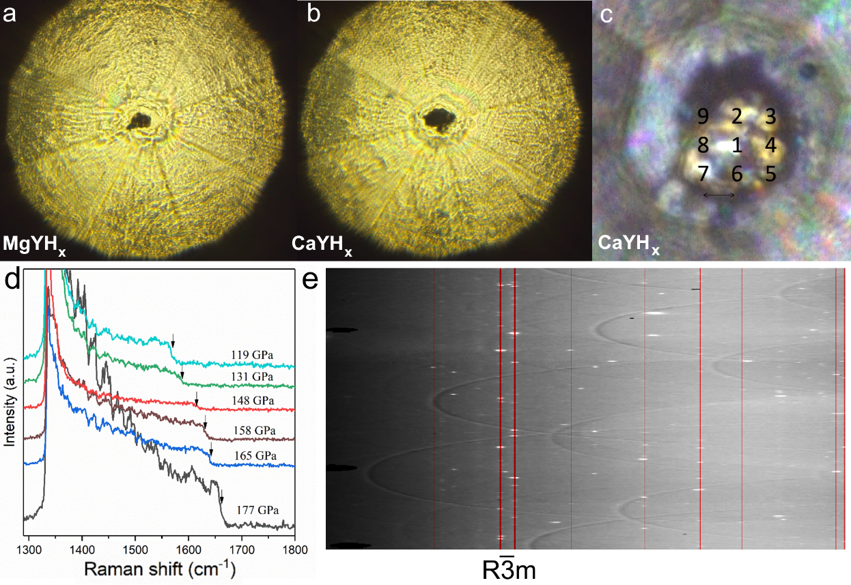

**Figure 2.** Optical photography of diamond anvils of DAC MgY (a**,** 175 GPa) and DAC CaY (b, at 177 GPa). Mapping the area of X-ray diffraction analysis of the CaYHx sample. (d) Raman spectra of the DAC CaY recorded during decompression. The arrows in the figure indicate the frequency points which were used to calculate the pressure. (e) Typical diffraction pattern (“cake”) of a CaYHx sample at 177 GPa. The red lines correspond to the XRD pattern of CaYH10.

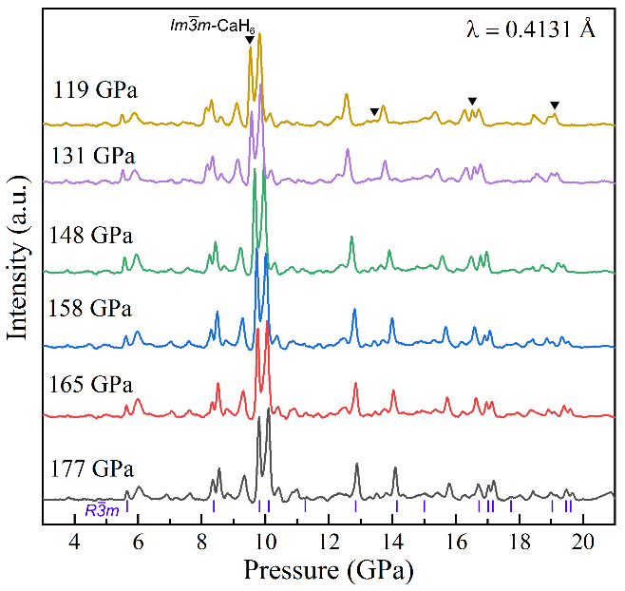

**Figure 3.** XRD patterns of sample CaYHx obtained from DAC CaY at 177 GPa (a, b) and in 119-177 GPa pressure range (right panel) during decompression of the cell. The experimental data and fitted line are shown in red and blue, respectively. In panel (a), the refinement was carried out only for the phases CaH6 and (Ca,Y)H5. In panel (b) an example of the structure of CaYH10 is shown, which could explain the appearance of superstructure reflections in addition to the expected spectrum of the *R $\overline{3}$ m* phase.

**Table 2.** Experimental unit cell parameters of *Imm*-CaH6 (Z=2) and *Rm*-(Ca,Y)H5 (Z = 3).

|  |  |  |  |  |  |
| --- | --- | --- | --- | --- | --- |
| **Pressure, GPa** | **a, Å** | **V, Å3** | **a, Å** | **c, Å** | **V, Å3** |
| 177 | 3.421 | 40.04 | 4.841 | 2.832 | 57.48 |
| 165 | 3.433 | 40.46 | 4.857 | 2.841 | 58.05 |
| 158 | 3.443 | 40.81 | 4.873 | 2.851 | 58.63 |
| 148 | 3.467 | 41.67 | 4.905 | 2.869 | 59.78 |
| 131 | 3.505* | 43.06 | 4.957 | 2.900 | 61.69 |
| 119 | 3.515 (с = 3.545)* | 43.80 | 4.972 | 2.909 | 62.27 |

* Tetragonal distortion

The main reaction product needs to be discussed. The hydrogen content in it is below the level of hexahydrides (CaH6 and YH6), and in the first approximation can be described as ~5 H atoms per a metal atom. The fact is that usually metal atoms in ternary hydrides are randomly mixed in the metal sublattice of such compounds (e.g., La-Y-H [Materials Today 2021], La-Nd-H, Ca-Nd-Zr-H [D. Semenok, private communication]). The black line (marked *R $\overline{3}$ m*) in Figure 3b shows how the *Rm*-(Ca,Y)H5 phase should look if it was a case of a solid solution of Ca and Y atoms. Only a few broad reflections (such as 2 $\overline{1}$ 0, 101, 1 $\overline{1}$ 1 etc.) would have to take place, as was observed for the initial hydrides (Mg,Y)2H5-x and (Ca,Y)2H5. However, we see well-defined, narrow, superstructural reflections: (100), (001), (200), (2 $\overline{1}$ 1), (3 $\overline{1}0$), (002) (see Figure 3a), which correspond to single crystal point reflections (Figure 2e).

All these facts indicate that the main phase can be a true ternary polyhydride CaYH10 (instead of (Ca,Y)H5,Ca:Y ratio is expected to be close to 1:1) with certain positions of Ca and Y atoms and their individual sublattices, reflections from which we observe in the XRD patterns. This compound could be the first example of such true ternary polyhydride synthesized at high pressure.

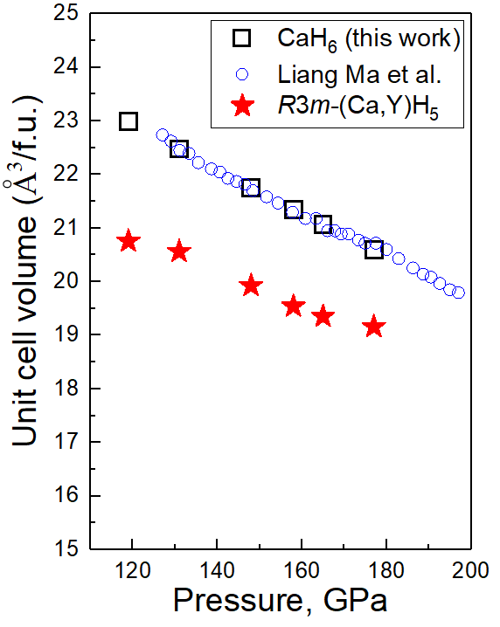

**Figure 4.** Pressure–unit cell volume diagram for Ca,Y polyhydrides: blue circles - CaH6 [Liang Ma et al., <https://arxiv.org/abs/2103.16282>], black squares – CaH6 in this work, red stars - *Rm*-(Ca,Y)H5.

**Additional experiment - Cs/CsAB system**

Due to the fact that the beamtime was not completely spent, and the diffraction from the DAC MgY could not be detected, we used the rest of the beamtime to study cesium hydrides at low pressure (0-30 GPa).

Cesium is an active alkaline earth metal, which, according to *ab initio* calculations, reacts with hydrogen to form polyhydrides already at a low pressure of 10-30 GPa [Andrew Shamp, James Hooper, and Eva Zurek, *Inorganic Chemistry, 51*, 9333-9342  (2012 )]. High reactivity of this metal and its hydride (CsH), as well as the very low melting point of cesium and high surface tension in the liquid state, seriously complicates the study of reactions of Cs (or CsH) with hydrogen at high pressure. A popular method for the synthesis of polyhydrides in high-pressure diamond cells - is the heating of metal precursors with ammonia borane (NH3BH3, AB), which at high temperatures serves as a source of hydrogen. This method cannot be directly applied to Cs, since Cs reacts very violently with crystalline ammonia borane to form the high temperature modification HT-CsAB [Dalton Trans., 2017, 46, 16315]. A more accurate reaction in a solution of AB in tetrahydrofuran leads to the formation of a low-temperature modification LT-CsAB [Dalton Trans., 2017, 46, 16315]. Both Cs amidoborane modifications no longer enters into further reactions with metallic cesium. We confirmed formation of amidoborane CsAB by Raman spectroscopy (Figure 5).

Using Raman spectroscopy, we have shown that laser heating of cesium amidoborane with gold particle (target) leads to its decomposition with hydrogen emission (Figure 6).

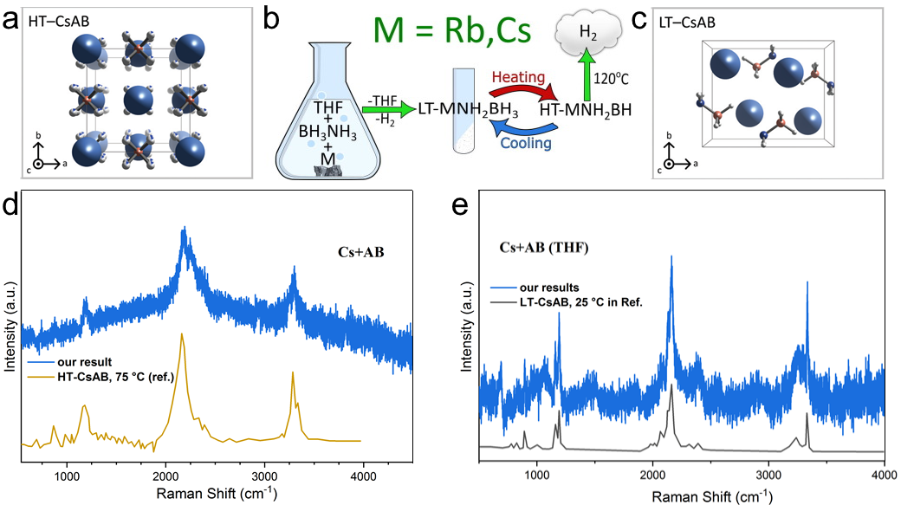

**Figure 5.** Scheme of СsAB synthesis (b), low-temperature (c) and high-temperature (a) crystalline modifications of cesium amidoborane at 0 GPa and their Raman spectra (532 nm, d, e) recorded in diamond anvil cells.

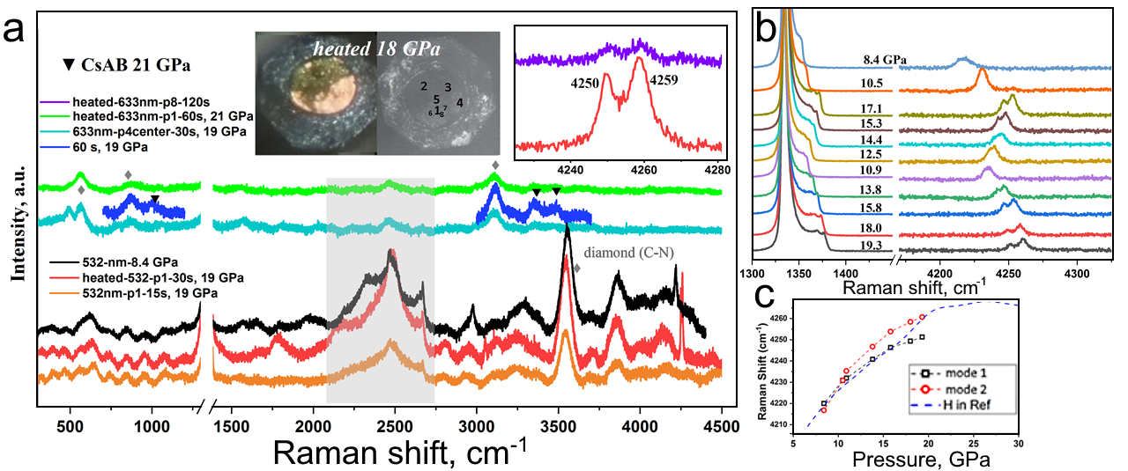  
**Figure 6.** Laser heating of CsAB with gold foil. Raman spectra (a, b) indicates the formation of molecular hydrogen. The splitting of the hydrogen peak points to bound H2.

In this experiment, the Cs/LT-CsAB mixture was loaded into a Mao-type diamond cell with an anvil culet diameter of 250 μm and a hole in the Re gasket of 150 μm. After increasing the pressure to 40 GPa, intense laser heating of the sample and Cs/LT-CsAB was carried out (see [https://www.youtube.com/watch?v=R2MGOXMX_K4]). As a result of heating, all the metallic cesium reacted. Using the SPring-8 synchrotron radiation source, we investigated various areas of the sample, for example, point “C”, which was not heated by the laser, and the center (“center”) of the cell, heated by the laser. Comparison of the diffraction patterns (Figure 7a, b) shows that the main component of the mixture is cesium amidoborane, which, under pressure, probably undergoes a phase transition into a new, previously unexplored modification (HP-CsAB).

The impurity phase to CsAB is the product of the reaction of cesium with hydrogen, which occurs during the thermal decomposition of CsAB, which turns out to be *Cmcm*-CsH (Figure 7c), which undergoes a phase transformation into *Pm $\overline{3}$ m*-CsH below 15 GPa, in accordance with the literature data [PRL, Vol. 74, 12, 1995]. There is also an additional unknown phase, the concentration of which, however, is not high enough for a confident interpretation.

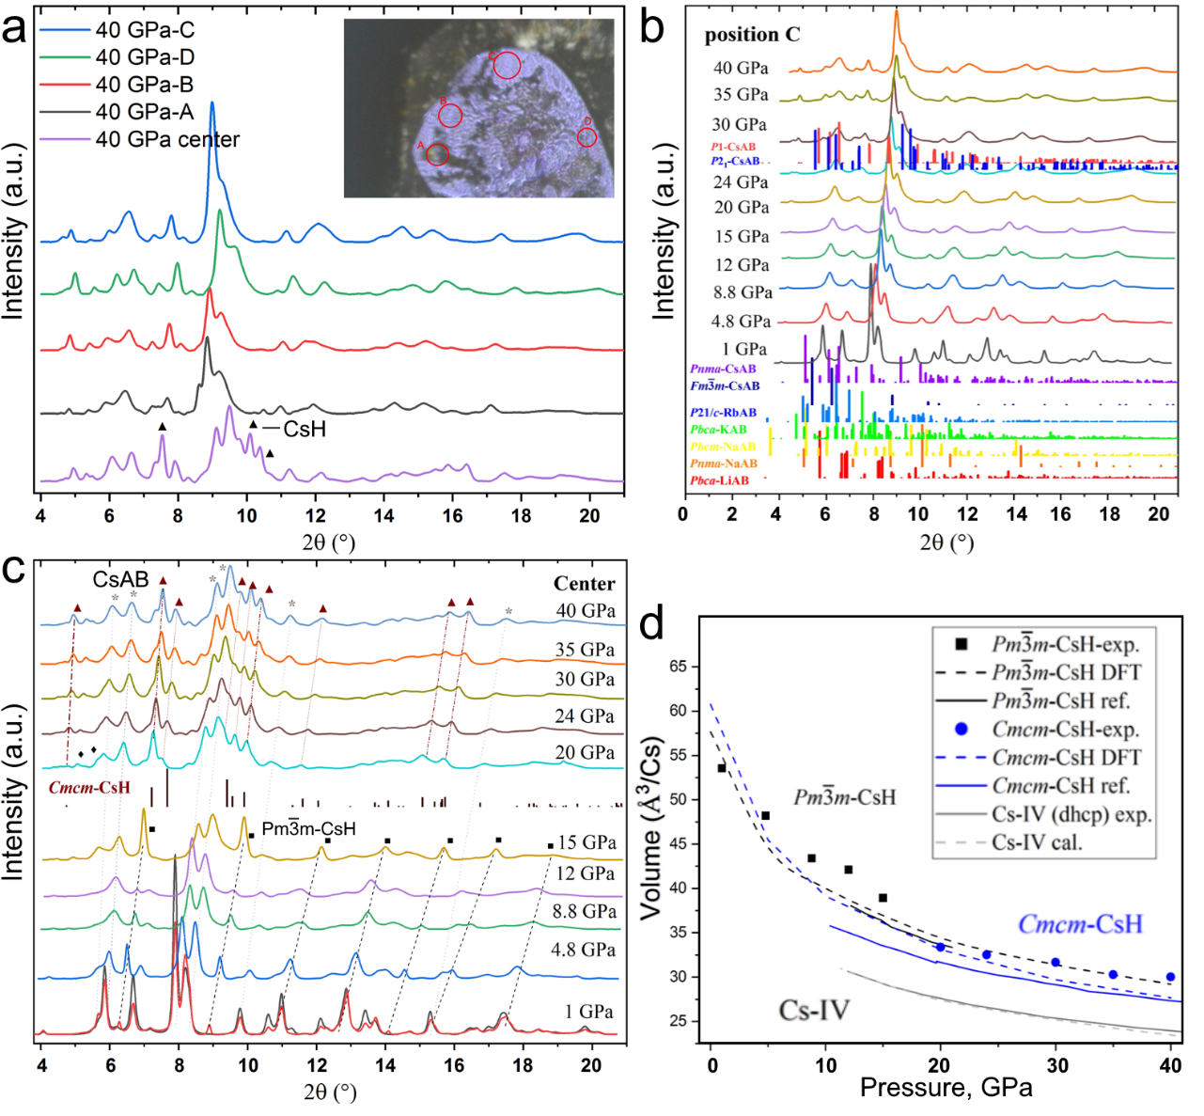

**Figure 7.** XRD patterns of Cs/CsHx/CsAB mixture after laser heating. (a) Comparison of diffraction patterns for heated (“center”) and unheated (A-D) areas of the sample. In the center, there are additional diffraction peaks from the reaction product - CsH. (b) Comparison of the diffraction pattern for HP-CsAB, obtained in our experiment, with previously studied amidoboranes of various alkali metals. None of the previously studied amidoboranes can explain the observed diffraction pattern. (с) Change of XRD patterns in the central part of the sample during DAC decompression from 40 to 1 GPa. (d) Comparison of experimental cell parameters of CsH with the results of previous studies. The error in the cell volume reaches 7-8%, which may indicate a non-stoichiometric composition of cesium hydride (CsH1+x).

**Conclusion:** this experiment showed that cesium hydrides can be obtained as the main product from Cs/CsAB if more intense laser heating of cesium amidoborane is carried out. This experiment shows the formation of monohydrides *Pm $\overline{3}$ m*-CsH and *Cmcm*-CsH from Cs/CsAB. The next task is to increase the hydrogen content in cesium hydrides. Cesium hydrides and CsAB are transparent in the visible and near-IR range, which makes it impossible to continue laser heating as soon as the cesium metal particle has reacted. To improve the process of laser heating, it is proposed to add gold foil as an absorber of IR laser radiation.

Thus, the plan for further experiments on the synthesis of cesium hydrides is as follows:

1. X-ray diffraction of CsAB and Au/LT-CsAB gold foil before and after the laser heating.

2. X-ray diffraction of Cs/Au/LT-CsAB after laser heating.

**References**